**AP AGING REPORT DOC**

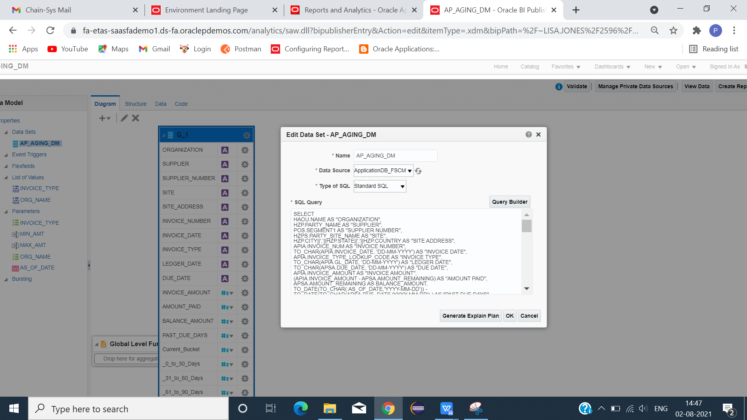

CLICK -> NEW -> DATAMODEL.

TYPE AP AGING QUERY.

**DATA MODEL QUERY**

SELECT

HAOU.NAME AS "ORGANIZATION",

HZP.PARTY_NAME AS "SUPPLIER",

POS.SEGMENT1 AS "SUPPLIER NUMBER",

HZPS.PARTY_SITE_NAME AS "SITE",

HZP.CITY||','||HZP.STATE||','||HZP.COUNTRY AS "SITE ADDRESS",

APIA.INVOICE_NUM AS "INVOICE NUMBER",

TO_CHAR(APIA.INVOICE_DATE, 'DD-MM-YYYY') AS "INVOICE DATE",

APIA.INVOICE_TYPE_LOOKUP_CODE AS "INVOICE TYPE",

TO_CHAR(APIA.GL_DATE, 'DD-MM-YYYY') AS "LEDGER DATE",

TO_CHAR(APSA.DUE_DATE, 'DD-MM-YYYY') AS "DUE DATE",

APIA.INVOICE_AMOUNT AS "INVOICE AMOUNT",

(APIA.INVOICE_AMOUNT - APSA.AMOUNT_REMAINING) AS "AMOUNT PAID",

APSA.AMOUNT_REMAINING AS BALANCE_AMOUNT,

TO_DATE(TO_CHAR(:AS_OF_DATE,'YYYY-MM-DD')) - TO_DATE(TO_CHAR(APSA.DUE_DATE,'YYYY-MM-DD') ) AS "PAST DUE DAYS",

CASE WHEN TO_DATE(TO_CHAR(:AS_OF_DATE,'YYYY-MM-DD')) - TO_DATE(TO_CHAR(APSA.DUE_DATE,'YYYY-MM-DD') )>= -999 AND

TO_DATE(TO_CHAR(:AS_OF_DATE,'YYYY-MM-DD')) - TO_DATE(TO_CHAR(APSA.DUE_DATE,'YYYY-MM-DD') )<0

THEN APSA.AMOUNT_REMAINING ELSE 0 END "Current Bucket",

CASE WHEN TO_DATE(TO_CHAR(:AS_OF_DATE,'YYYY-MM-DD')) - TO_DATE(TO_CHAR(APSA.DUE_DATE,'YYYY-MM-DD') ) >= 0 AND

TO_DATE(TO_CHAR(:AS_OF_DATE,'YYYY-MM-DD')) - TO_DATE(TO_CHAR(APSA.DUE_DATE,'YYYY-MM-DD') )<= 30

THEN APSA.AMOUNT_REMAINING ELSE 0 END "0 to 30 Days",

CASE WHEN TO_DATE(TO_CHAR(:AS_OF_DATE,'YYYY-MM-DD')) - TO_DATE(TO_CHAR(APSA.DUE_DATE,'YYYY-MM-DD') )>= 31 AND

TO_DATE(TO_CHAR(:AS_OF_DATE,'YYYY-MM-DD')) - TO_DATE(TO_CHAR(APSA.DUE_DATE,'YYYY-MM-DD') )<= 60

THEN APSA.AMOUNT_REMAINING ELSE 0

END "31 to 60 Days",

CASE WHEN TO_DATE(TO_CHAR(:AS_OF_DATE,'YYYY-MM-DD')) - TO_DATE(TO_CHAR(APSA.DUE_DATE,'YYYY-MM-DD') )>= 61 AND

TO_DATE(TO_CHAR(:AS_OF_DATE,'YYYY-MM-DD')) - TO_DATE(TO_CHAR(APSA.DUE_DATE,'YYYY-MM-DD') )<= 90

THEN APSA.AMOUNT_REMAINING ELSE 0

END "61 to 90 Days",

CASE WHEN TO_DATE(TO_CHAR(:AS_OF_DATE,'YYYY-MM-DD')) - TO_DATE(TO_CHAR(APSA.DUE_DATE,'YYYY-MM-DD') )>= 91 AND

TO_DATE(TO_CHAR(:AS_OF_DATE,'YYYY-MM-DD')) - TO_DATE(TO_CHAR(APSA.DUE_DATE,'YYYY-MM-DD') )<= 120

THEN APSA.AMOUNT_REMAINING ELSE 0

END "91 to 120 Days",

CASE WHEN TO_DATE(TO_CHAR(:AS_OF_DATE,'YYYY-MM-DD')) - TO_DATE(TO_CHAR(APSA.DUE_DATE,'YYYY-MM-DD') )>= 121 AND

TO_DATE(TO_CHAR(:AS_OF_DATE,'YYYY-MM-DD')) - TO_DATE(TO_CHAR(APSA.DUE_DATE,'YYYY-MM-DD') )<= 999999

THEN APSA.AMOUNT_REMAINING ELSE 0

END "More than 120 Days"

FROM

HR_ALL_ORGANIZATION_UNITS HAOU,

HZ_PARTIES HZP,

HZ_PARTY_SITES HZPS,

POZ_SUPPLIERS POS,

AP_INVOICES_ALL APIA,

AP_PAYMENT_SCHEDULES_ALL APSA

WHERE 1=1

AND APIA.ORG_ID = HAOU.ORGANIZATION_ID(+)

AND APIA.PARTY_ID = HZP.PARTY_ID(+)

AND APIA.PARTY_SITE_ID = HZPS.PARTY_SITE_ID(+)

AND APIA.VENDOR_ID = POS.VENDOR_ID(+)

AND APIA.INVOICE_ID = APSA.INVOICE_ID(+)

AND HAOU.NAME = NVL (:ORG_NAME,HAOU.NAME)

AND APIA.GL_DATE <= NVL( :AS_OF_DATE,TRUNC(SYSDATE))

AND APIA.INVOICE_TYPE_LOOKUP_CODE = NVL( :INVOICE_TYPE,APIA.INVOICE_TYPE_LOOKUP_CODE)

AND APIA.INVOICE_AMOUNT >= NVL( :MIN_AMT,0)

AND APIA.INVOICE_AMOUNT <= NVL( :MAX_AMT,999999)

AND APSA.AMOUNT_REMAINING != APIA.INVOICE_AMOUNT

AND APSA.AMOUNT_REMAINING > 0

AND APIA.GL_DATE != APSA.DUE_DATE

ORDER BY

POS.SEGMENT1,

APIA.INVOICE_NUM

**PARAMETERS**

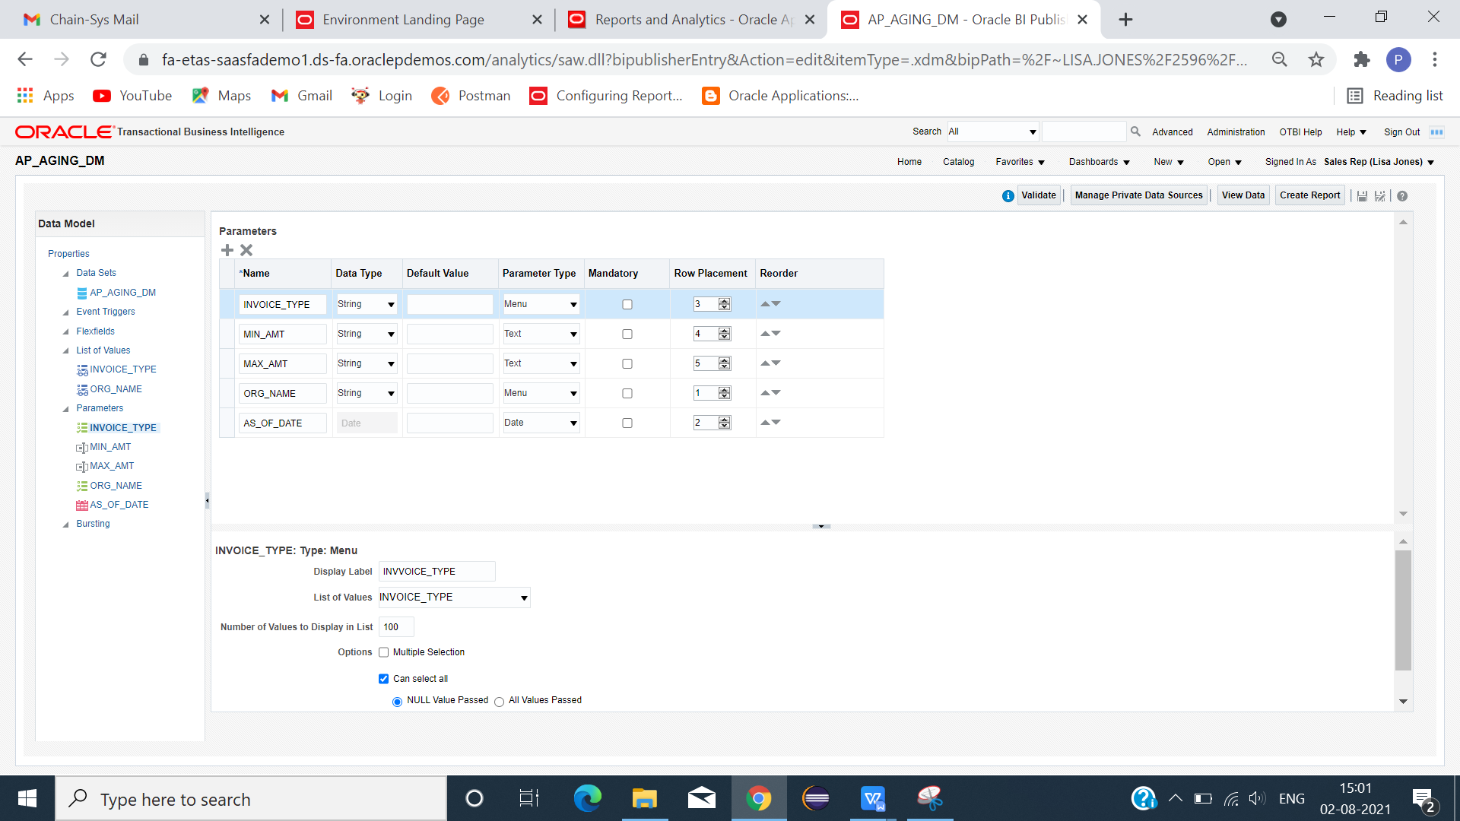

**LIST OF VALUES QUERY**

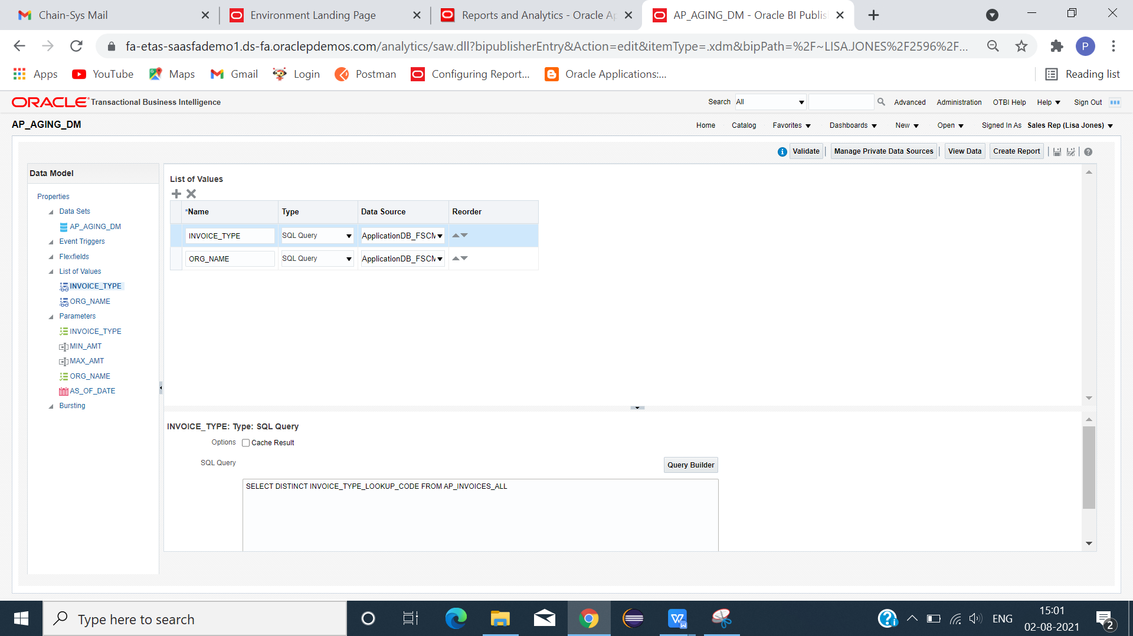

**INVOICE_TYPE:**

**SELECT DISTINCT INVOICE_TYPE_LOOKUP_CODE FROM AP_INVOICES_ALL**

**ORG_NAME:**

SELECT DISTINCT NAME FROM HR_ALL_ORGANIZATION_UNITS

WHERE NAME IN ('US1 Business Unit', 'Progress US Business Unit')

CLICK DATA -> SAVE -> VIEW -> VIEW SAMPLE DATA -> SAVE -> EXPORT(XML FILE).

**EXCEL TEMPLATE**

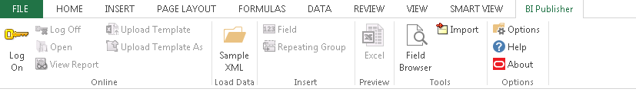

CLICK SAMPLE XML(LOAD DATA) - > LOAD XML FILE -> FIELD(META DATA CREATED) .

INSERT COLUMNS USING FIELDS(PARAMETER AND REQUIRED COLUMNS).

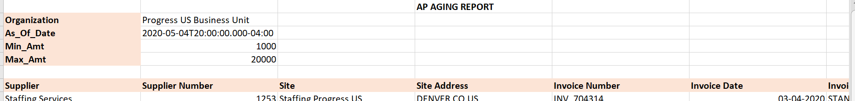

SAVE TEMPLATE AS (EXCEL 2003 WORKBOOK) FORMAT.

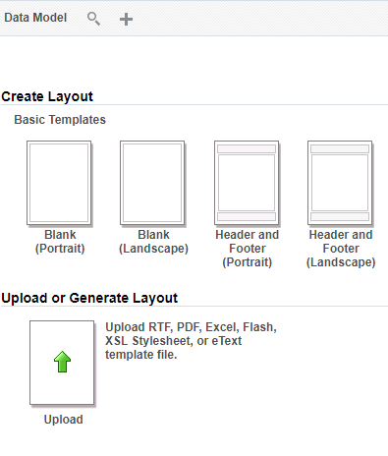

LOAD DATA MODE -> CLICK UPLOAD OR GENERATE LAYOUT.

GIVE LAYOUT NAME -> LOAD TEMPLATE -> CHOOSE TEMPLATE FORMAT -> LOCALE -> OK

SAVE -> REPORT -> RUN

REPORT SUCCESSFULLY GENERATED IN EXCEL FORMAT.

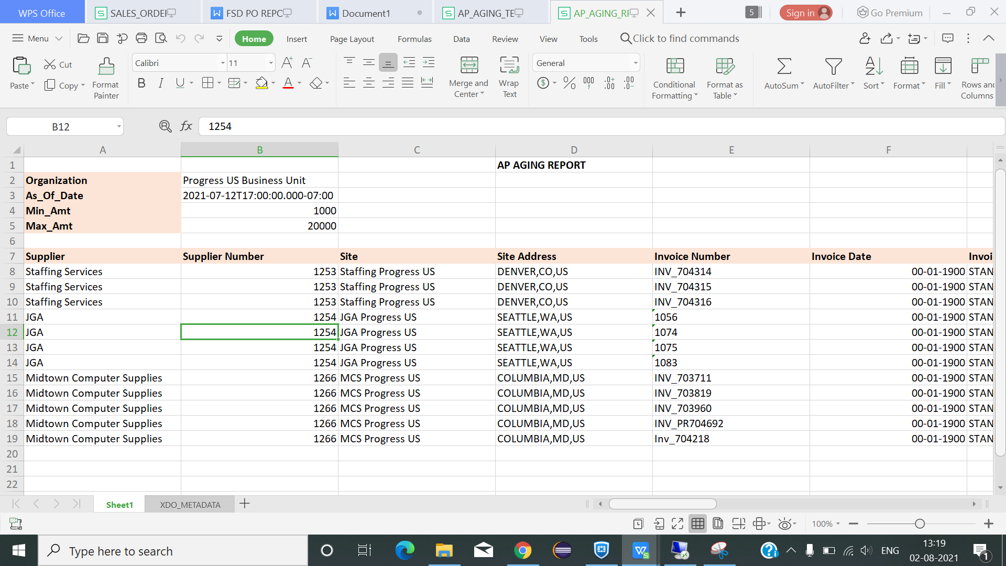

FINAL OUTPUT RESULT IN EXCEL FORMAT.

===================================================================================